Create Simple PHP 8 CRUD REST API with MySQL & PHP PDO
Last updated on by Digamber
This is a step by step PHP 8 & MySQL REST API tutorial, In this tutorial i am going to share with you how to create a PHP 8 CRUD (Create, Read, Update, Delete) RESTful API with MySQL database.
If you aspire to hold a fundamental understanding of PHP frameworks, then you must check out our previous tutorial where we described How to Create a PHP Laravel 6 CRUD Web App with MySQL.
This tutorial is going to cover how to build simple CRUD REST API in PHP and MySQL, Test PHP RESTful API with Postmen and Setup PHP development environment on your local development system from scratch.

Table of Contents
- API (Application Programming Interface)
- What is REST API?
- PHP REST API File Structure
- MySQL Database Configuration
- Make MySQL Database Connection
- Create PHP Class
- Fetch MySQL Table Records
- Get Single Row from MySQL Database via PHP API
- Add/Insert Single Record
- Edit/Update Mysql Table
- Remove/Delete Single Mysql Record
- Summary

What is API (Application Programming Interface)?
API means Application Programming Interface, and It is a set of routines, protocols, and tools for creating software applications. An API interface makes communication possible between various software components.
In software development, API is a URL that handles the data for the web application through HTTP Requests GET, POST, UPDATE & DELETE, and manages the CRUD operations.

What is REST API?
Representational state transfer (REST) is a software architectural style that defines a set of constraints to be used for creating Web services. Web services that conform to the REST architectural style, called RESTful Web services, provide interoperability between computer systems on the Internet. RESTful Web services allow the requesting systems to access and manipulate textual representations of Web resources by using a uniform and predefined set of stateless operations. Other kinds of Web services, such as SOAP Web services, expose their own arbitrary sets of operations.
source: wikipedia

PHP 8 API Project File Structure
This is going to be the file structure of our PHP 8 REST API project, we created api, class and config folders to store the API and MySQL database related configurations files.
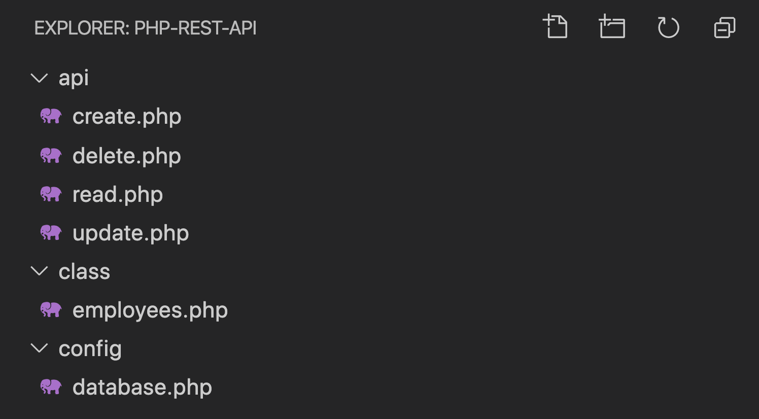
You can run your PHP project through MAMP or WAMP however we are using the command line tool to start the PHP project.
Navigate to the directory where you have located your PHP project.
cd php-project-name
Bash
Once you are in the project folder then run the following command to start the PHP app.
php -S 127.0.0.1:8080
Bash
Following output will be displayed on your terminal screen.
PHP 7.3.11 Development Server started at Thu May 7 13:21:35 2020
Listening on http://127.0.0.1:8080
Document root is /Users/digamber/Desktop/php-rest-api
Bash
Check your project on the following url: http://127.0.0.1:8080

MySQL Database Configuration
Before we get started we need to create a phpapidb database, well this can be done through two methods either you can use the PhpMyAdmin, or you can do it by accessing the MySQL root user via the terminal or command-line tool to create the Database.
We have written a detailed article on Installing and Setting up MySQL in Mac’s Terminal app.
We are accessing the root user via command-line to create the database.
mysql -u root -p
Bash
Create a new MySQL database.
CREATE DATABASE phpapidb;
Bash
Check the database.
SHOW DATABASES;

+--------------------+
| Database |
+--------------------+
| information_schema |
| mysql |
| performance_schema |
| phpapidb |
| sys |
+--------------------+
Bash
Use the database.
use phpapidb;
Bash
Once you are done with the database creation, then you should run the SQL script to create the table.
CREATE TABLE IF NOT EXISTS `Employee` (
`id` int(11) NOT NULL AUTO_INCREMENT,
`name` varchar(256) NOT NULL,
`email` varchar(50),
`age` int(11) NOT NULL,
`designation` varchar(255) NOT NULL,
`created` datetime NOT NULL,
PRIMARY KEY (`id`)
)ENGINE=InnoDB DEFAULT CHARSET=utf8 AUTO_INCREMENT=19;
Bash
Make sure what table you have created.
SHOW tables;

+--------------------+
| Tables_in_phpapidb |
+--------------------+
| Employee |
+--------------------+
Bash
Populate data into the `Employee` table.
INSERT INTO `Employee` (`id`, `name`, `email`, `age`, `designation`, `created`) VALUES
(1, 'John Doe', 'johndoe@gmail.com', 32, 'Data Scientist', '2012-06-01 02:12:30'),
(2, 'David Costa', 'sam.mraz1996@yahoo.com', 29, 'Apparel Patternmaker', '2013-03-03 01:20:10'),
(3, 'Todd Martell', 'liliane_hirt@gmail.com', 36, 'Accountant', '2014-09-20 03:10:25'),
(4, 'Adela Marion', 'michael2004@yahoo.com', 42, 'Shipping Manager', '2015-04-11 04:11:12'),
(5, 'Matthew Popp', 'krystel_wol7@gmail.com', 48, 'Chief Sustainability Officer', '2016-01-04 05:20:30'),
(6, 'Alan Wallin', 'neva_gutman10@hotmail.com', 37, 'Chemical Technician', '2017-01-10 06:40:10'),
(7, 'Joyce Hinze', 'davonte.maye@yahoo.com', 44, 'Transportation Planner', '2017-05-02 02:20:30'),
(8, 'Donna Andrews', 'joesph.quitz@yahoo.com', 49, 'Wind Energy Engineer', '2018-01-04 05:15:35'),
(9, 'Andrew Best', 'jeramie_roh@hotmail.com', 51, 'Geneticist', '2019-01-02 02:20:30'),
(10, 'Joel Ogle', 'summer_shanah@hotmail.com', 45, 'Space Sciences Teacher', '2020-02-01 06:22:50');
Bash
If you are using PHP with MySQL 8.0+ you might get this error: The server requested authentication method unknown to the client
MySQL 8 uses auth_socket as a default plugin, so your applications require you to log in to your database using a password. You have to log in as root to mysql by using the following SQL script.
ALTER USER 'root'@'localhost' IDENTIFIED WITH mysql_native_password BY 'password';
Bash
- You need to replace 'password' with your root password.
- If your app is not logged in to your database with the root user, then replace the 'root' user in the above command with the user that your application is using.

Make Database Connection
The following code holds the MySQL database details such as db name, user name and password. It makes the database connection with PHP using the PDO.
The PHP Data Objects (PDO) extension specifies a lightweight, consistent interface for accessing databases in PHP. Every database driver that implements the PDO interface can expose database-specific features as regular extension functions. Note that you cannot perform any database functions using the PDO extension by itself; you must use a database-specific PDO driver to access a database server.
source – php.net
Create the config folder inside the PHP API project, also create the database.php file and place the following code.
<?php
class Database {
private $host = "127.0.0.1";
private $database_name = "phpapidb";
private $username = "root";
private $password = "xxxxxxxx";

public $conn;

public function getConnection(){
$this->conn = null;
try{
$this->conn = new PDO("mysql:host=" . $this->host . ";dbname=" . $this->database_name, $this->username, $this->password);
$this->conn->exec("set names utf8");
}catch(PDOException $exception){
echo "Database could not be connected: " . $exception->getMessage();
}
return $this->conn;
}
}
?>
PHP

Create PHP Class
Now, we will create the PHP Class by the name of Employee. The PHP Classes are used to execute Object-Oriented Programming in PHP. PHP Classes encapsulate the values of the table for the Database. We will define the values that are stored in the variable form in the SQL table.
The SQL table properties are associated with the Connection class that is added via the constructor class.
Each object class contains the CRUD method that is being operated via the PHP functions to perform the CREATE, READ, UPDATE & DELETE operations for the defined table rows.
Create class/employees.php file and define the CRUD methods inside the Employee class.
<?php
class Employee{

// Connection
private $conn;

// Table
private $db_table = "Employee";

// Columns
public $id;
public $name;
public $email;
public $age;
public $designation;
public $created;

// Db connection
public function __construct($db){
$this->conn = $db;
}

// GET ALL
public function getEmployees(){
$sqlQuery = "SELECT id, name, email, age, designation, created FROM " . $this->db_table . "";
$stmt = $this->conn->prepare($sqlQuery);
$stmt->execute();
return $stmt;
}

// CREATE
public function createEmployee(){
$sqlQuery = "INSERT INTO
". $this->db_table ."
SET
name = :name,
email = :email,
age = :age,
designation = :designation,
created = :created";

$stmt = $this->conn->prepare($sqlQuery);

// sanitize
$this->name=htmlspecialchars(strip_tags($this->name));
$this->email=htmlspecialchars(strip_tags($this->email));
$this->age=htmlspecialchars(strip_tags($this->age));
$this->designation=htmlspecialchars(strip_tags($this->designation));
$this->created=htmlspecialchars(strip_tags($this->created));

// bind data
$stmt->bindParam(":name", $this->name);
$stmt->bindParam(":email", $this->email);
$stmt->bindParam(":age", $this->age);
$stmt->bindParam(":designation", $this->designation);
$stmt->bindParam(":created", $this->created);

if($stmt->execute()){
return true;
}
return false;
}

// READ single
public function getSingleEmployee(){
$sqlQuery = "SELECT
id,
name,
email,
age,
designation,
created
FROM
". $this->db_table ."
WHERE
id = ?
LIMIT 0,1";

$stmt = $this->conn->prepare($sqlQuery);

$stmt->bindParam(1, $this->id);

$stmt->execute();

$dataRow = $stmt->fetch(PDO::FETCH_ASSOC);

$this->name = $dataRow['name'];
$this->email = $dataRow['email'];
$this->age = $dataRow['age'];
$this->designation = $dataRow['designation'];
$this->created = $dataRow['created'];
}

// UPDATE
public function updateEmployee(){
$sqlQuery = "UPDATE
". $this->db_table ."
SET
name = :name,
email = :email,
age = :age,
designation = :designation,
created = :created
WHERE
id = :id";

$stmt = $this->conn->prepare($sqlQuery);

$this->name=htmlspecialchars(strip_tags($this->name));
$this->email=htmlspecialchars(strip_tags($this->email));
$this->age=htmlspecialchars(strip_tags($this->age));
$this->designation=htmlspecialchars(strip_tags($this->designation));
$this->created=htmlspecialchars(strip_tags($this->created));
$this->id=htmlspecialchars(strip_tags($this->id));

// bind data
$stmt->bindParam(":name", $this->name);
$stmt->bindParam(":email", $this->email);
$stmt->bindParam(":age", $this->age);
$stmt->bindParam(":designation", $this->designation);
$stmt->bindParam(":created", $this->created);
$stmt->bindParam(":id", $this->id);

if($stmt->execute()){
return true;
}
return false;
}

// DELETE
function deleteEmployee(){
$sqlQuery = "DELETE FROM " . $this->db_table . " WHERE id = ?";
$stmt = $this->conn->prepare($sqlQuery);

$this->id=htmlspecialchars(strip_tags($this->id));

$stmt->bindParam(1, $this->id);

if($stmt->execute()){
return true;
}
return false;
}

}
?>
PHP
The Employee class manages the CRUD operation
- __construct() — Makes the database connection ready.
- getEmployees() — Get all records.
- getSingleEmployee() — Get single records.
- createEmployee() — Create record.
- updateEmployee() — Update record.
- deleteEmployee() — Fetch single record.

Fetch MySQL Table Records using PHP REST API Endpoint
The following code retrieves all the records from MySQL table. So create read.php file in the api folder and place the following code.
<?php
header("Access-Control-Allow-Origin: *");
header("Content-Type: application/json; charset=UTF-8");

include_once '../config/database.php';
include_once '../class/employees.php';

$database = new Database();
$db = $database->getConnection();

$items = new Employee($db);

$stmt = $items->getEmployees();
$itemCount = $stmt->rowCount();

echo json_encode($itemCount);

if($itemCount > 0){

$employeeArr = array();
$employeeArr["body"] = array();
$employeeArr["itemCount"] = $itemCount;

while ($row = $stmt->fetch(PDO::FETCH_ASSOC)){
extract($row);
$e = array(
"id" => $id,
"name" => $name,
"email" => $email,
"age" => $age,
"designation" => $designation,
"created" => $created
);

array_push($employeeArr["body"], $e);
}
echo json_encode($employeeArr);
}

else{
http_response_code(404);
echo json_encode(
array("message" => "No record found.")
);
}
?>
PHP
Let us test the PHP API Endpoint using Postman, open the Postman and use the following URL and click on the Send button to check the output.
Method | Endpoint
GET | http://localhost:8080/api/read.php
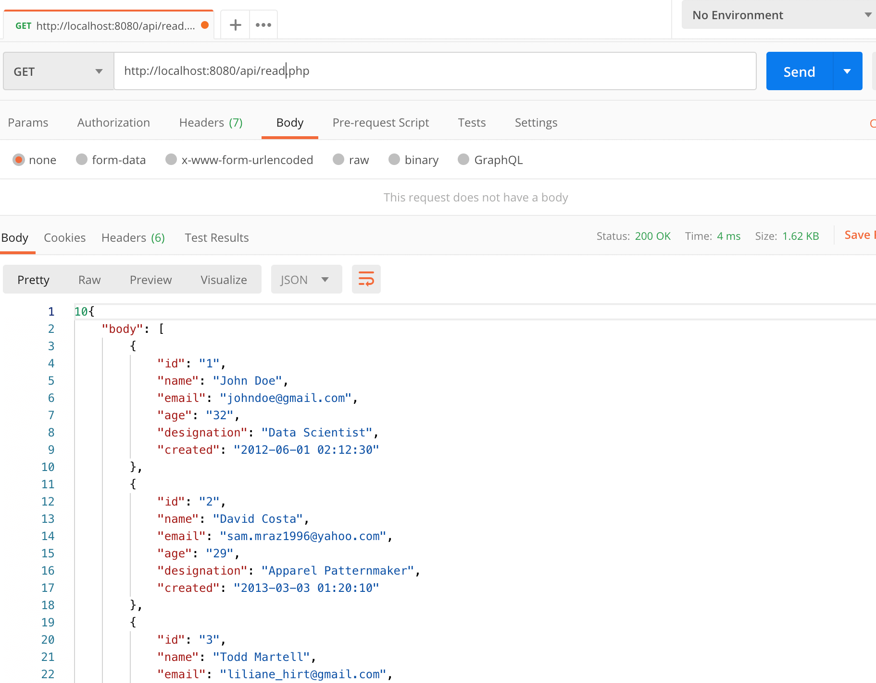

Get Single Row from MySQL Database via PHP API
The following code fetch single column from MySQL database’s table. Create single_read.php file in the api folder and place the following code.
The SELECT statement is being used here to get the table’s column, in the following code, we are selecting the Employee values from the MySQL table.
<?php
header("Access-Control-Allow-Origin: *");
header("Content-Type: application/json; charset=UTF-8");
header("Access-Control-Allow-Methods: POST");
header("Access-Control-Max-Age: 3600");
header("Access-Control-Allow-Headers: Content-Type, Access-Control-Allow-Headers, Authorization, X-Requested-With");

include_once '../config/database.php';
include_once '../class/employees.php';

$database = new Database();
$db = $database->getConnection();

$item = new Employee($db);

$item->id = isset($_GET['id']) ? $_GET['id'] : die();

$item->getSingleEmployee();

if($item->name != null){
// create array
$emp_arr = array(
"id" => $item->id,
"name" => $item->name,
"email" => $item->email,
"age" => $item->age,
"designation" => $item->designation,
"created" => $item->created
);

http_response_code(200);
echo json_encode($emp_arr);
}

else{
http_response_code(404);
echo json_encode("Employee not found.");
}
?>
PHP

Method | Endpoint
GET | localhost:8080/api/single_read.php/?id=2
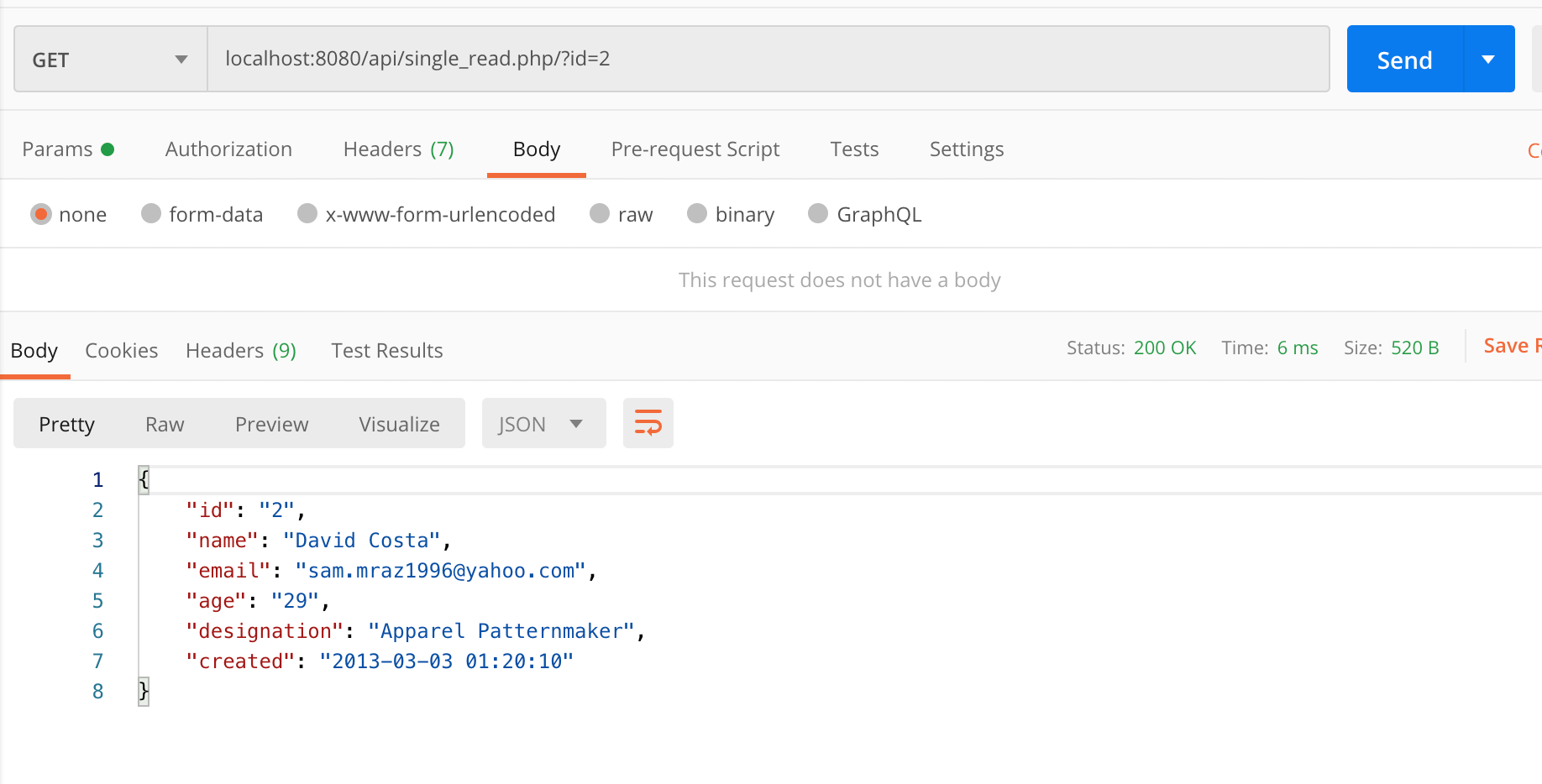

Insert or Add Single Record in MySQL Table
In this step we will create PHP REST API Endpoints to insert or add a single record in MySQL table.
Create create.php file in the api folder and add the following code.
<?php
header("Access-Control-Allow-Origin: *");
header("Content-Type: application/json; charset=UTF-8");
header("Access-Control-Allow-Methods: POST");
header("Access-Control-Max-Age: 3600");
header("Access-Control-Allow-Headers: Content-Type, Access-Control-Allow-Headers, Authorization, X-Requested-With");

include_once '../config/database.php';
include_once '../class/employees.php';

$database = new Database();
$db = $database->getConnection();

$item = new Employee($db);

$data = json_decode(file_get_contents("php://input"));

$item->name = $data->name;
$item->email = $data->email;
$item->age = $data->age;
$item->designation = $data->designation;
$item->created = date('Y-m-d H:i:s');

if($item->createEmployee()){
echo 'Employee created successfully.';
} else{
echo 'Employee could not be created.';
}
?>
PHP

Method | Endpoint
POST | http://localhost:8080/api/create.php
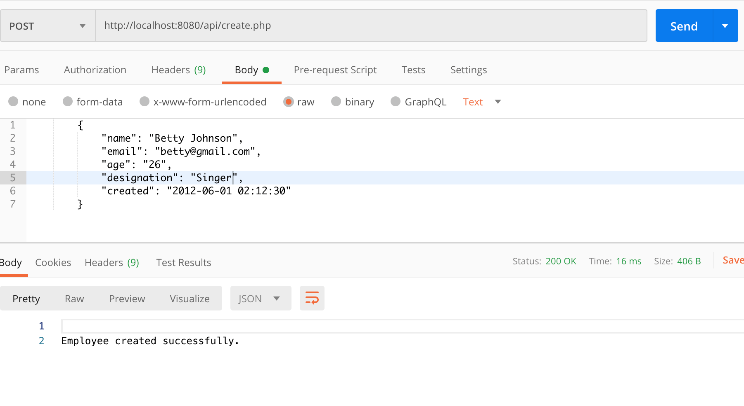

Edit/Update MySQL Table using PHP 8 API
This step explains to you how to Update or Edit the data for specific MySQL record. We can use the PHP 8 RESTful API to make the necessary update in the data that is stored in the MySQL database.
Create update.php file in the api folder and place the following code.
<?php
header("Access-Control-Allow-Origin: *");
header("Content-Type: application/json; charset=UTF-8");
header("Access-Control-Allow-Methods: POST");
header("Access-Control-Max-Age: 3600");
header("Access-Control-Allow-Headers: Content-Type, Access-Control-Allow-Headers, Authorization, X-Requested-With");

include_once '../config/database.php';
include_once '../class/employees.php';

$database = new Database();
$db = $database->getConnection();

$item = new Employee($db);

$data = json_decode(file_get_contents("php://input"));

$item->id = $data->id;

// employee values
$item->name = $data->name;
$item->email = $data->email;
$item->age = $data->age;
$item->designation = $data->designation;
$item->created = date('Y-m-d H:i:s');

if($item->updateEmployee()){
echo json_encode("Employee data updated.");
} else{
echo json_encode("Data could not be updated");
}
?>
PHP

Method | Endpoint
POST | http://localhost:8080/api/update.php
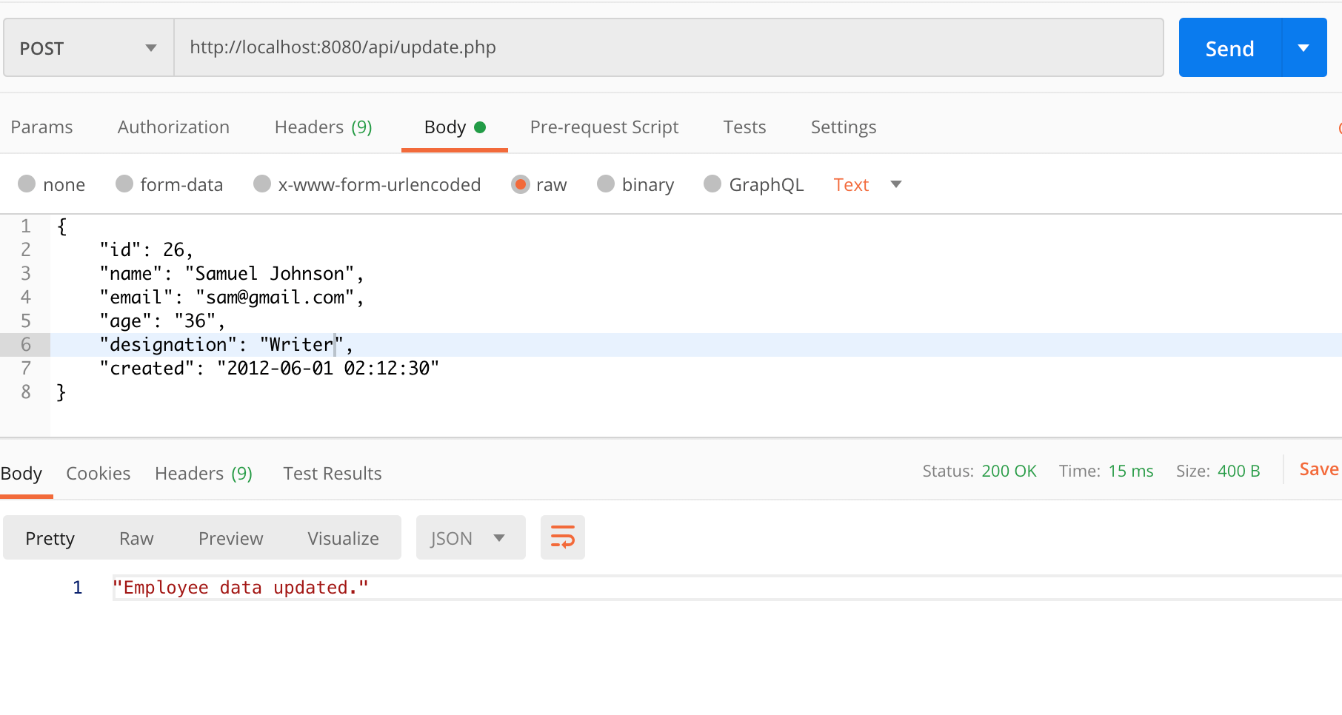

Remove/Delete Single Mysql Record using PHP API
Create delete.php file in api folder in this file we will write the login to delete or remove the single employee record from MySQL data table using PHP 8 RESTful API. We will make the API call using the deletedEmployee() method.
<?php
header("Access-Control-Allow-Origin: *");
header("Content-Type: application/json; charset=UTF-8");
header("Access-Control-Allow-Methods: POST");
header("Access-Control-Max-Age: 3600");
header("Access-Control-Allow-Headers: Content-Type, Access-Control-Allow-Headers, Authorization, X-Requested-With");

include_once '../config/database.php';
include_once '../class/employees.php';

$database = new Database();
$db = $database->getConnection();

$item = new Employee($db);

$data = json_decode(file_get_contents("php://input"));

$item->id = $data->id;

if($item->deleteEmployee()){
echo json_encode("Employee deleted.");
} else{
echo json_encode("Data could not be deleted");
}
?>
PHP

Method | Endpoint
DELETE | localhost:8080/api/delete.php
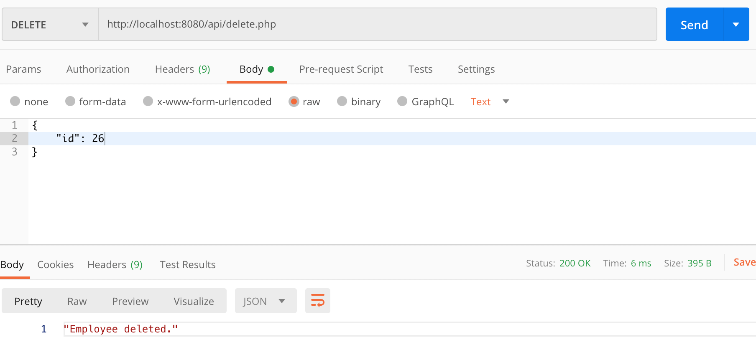

Summary
So this was it, in this tutorial we have learned how to create simple CRUD RESTful API with PHP 8 & MySQL 8, we also explored about the useful PHP methods such as htmlspecialchars(), bindParam(), execute(), PHP PDO and json_encode().
You can download the complete project files from GitHub.
https://www.positronx.io/create-simple-php-crud-rest-api-with-mysql-php-pdo/

